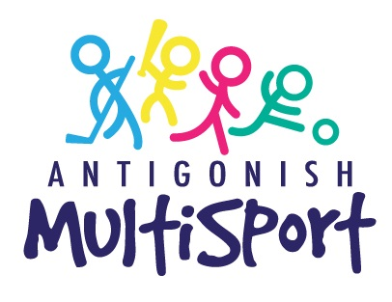

Parent/Guardian Handbook
2025-26

We want to help kids reach their potential in sport!
Antigonish Multisport is a collaborative project between 10 community sport organizations and 2 Municipal Recreation Departments, with the support of numerous community sport stakeholders (locally, provincially and nationally).

Our vision is to grow children through sport by providing opportunities to develop the skills and confidence to enjoy the positive benefits of a quality, first sport experience.

Our Goals
- Provide the opportunity for children to participate in a quality multisport experience with a physical literacy focus.
- Strengthen the mandate of community sport organizations in alignment with Sport for Life.
- Reduce barriers of participation in a quality sport program.
- Educate the community on the importance of physical literacy and long-term athlete development.
- Collectively build healthier communities through sport, with a focus on being Active for Life.

Our Community Sport Organization Partners

Our program is designed and led by volunteer community sport organizations. Without their commitment and dedication to growing children through sport in our community, our program would not be possible.

More information about each of these organizations can be found at the following:

Antigonish Baseball Association: https://playfinder.ca/Org/AntBbllABA
North Nova Highlander Girls Baseball: https://playfinder.ca/Org/AntBbllNNHB
Antigonish Minor Softball: https://playfinder.ca/Org/AntSBllAMSA
Xavier Taekwondo: http://www.xaviertaekwondo.com/
Antigonish Minor Hockey Association: https://antigonishminorhockey.ca/Home
https://playfinder.ca/Org/AntHckyAMHA
Antigonish Track Club: https://playfinder.ca/Org/AntTrckTrack
Antigonish Minor Basketball Association: https://playfinder.ca/Org/AntBkblAMBB
STFX Gymnastics: https://www.mystfx.ca/human-kinetics/stfx-community-recreational-gymnastics-program
First Tee Golf: https://firstteeatlantic.ca/ and https://playfinder.ca/Org/AntGolfAGC
Antigonish Celtics Soccer Club: https://playfinder.ca/Org/AntSoccCelt

PROGRAM INFORMATION

PROGRAM T-SHIRTS
T-Shirts will be sized for all participants on the program kick-off day and will be available as soon as possible. We ask that participants wear their shirt to all sessions (minus hockey and swimming) as the shirts will have your child’s name on them. This allows our recreation staff and changing community sport organizations to easily identify and engage with all participants throughout the year. We will have name tags for all children until the t-shirts come in.

DROP-OFF AND PICK-UP
Due to the nature of our program and availability of facilities required, we have some variance in our schedule, depending on which sport we are playing. The full calendar is included with this booklet.
Please drop off your children so they will be ready to participate at our start times. For all gym and pool-based sports, this will be approximately 10 minutes before the program starts. Please be ready to pick-up children at the end of the program. Please see the note below regarding hockey times. Parents/guardians must go with their child in and out of our program to ensure safety.

SPORT-SPECIFIC NOTES
Swimming
- Our swimming component is run in partnership with Antigonish County Recreation.
- Participants will follow a swim lesson based on the Lifesaving Society Swim for Life program through certified Lifesaving Swim Instructor (LSI).
- Children will be placed in appropriate levels based on their submitted swimming experience (groups may move around after the first session, based on ability). If your child has increased their swimming ability (either levels obtained or general ability) from what was submitted with the registration form, please send a quick note to our email address so we can make the adjustment before groups are made.
- One parent per household is permitted on the pool deck, no additional children permitted to be on the pool deck
- Children will be eligible to earn a swim level through this portion of the program.

Hockey
- Hockey block is scheduled for 8 sessions, as opposed to 5-6 for every other sport block. This is to allow for the increased time needed for developing the skill of skating.
- The first (October 27th) and last (November 21st) hockey session will be run at the Town of Antigonish arena, the remaining sessions will be at the StFX Aux Rink.
- For the first hockey session, please show up at least a half hour before the program starts to allow time for putting on gear.
- If participants have their own or access to borrowed gear, they are encouraged to use it.
- For those who do not have access to gear, it will be loaned out to participants. Arrangements for sizing, pick up, and return will be made with Antigonish Minor Hockey Association and will be communicated to parents. All loaned out hockey gear is the property of Antigonish Minor Hockey Association.
- Please ensure that the gear is properly dried out at home after each hockey session.
- A hockey jersey will also be loaned out to participants for their use during these sessions and will be returned when the hockey sessions are completed.
- If you are new to hockey and unsure of how to dress your child in gear, this may be helpful: http://eastcoastmommyblog.blogspot.ca/2014/08/tips-for-new-hockey-moms-getting.html
- With hockey gear, please wear:
  - Tight fitting clothing, with high socks
  - Hair tied back; low pony or braid
Gymnastics
- All gymnastics sessions will take place in the StFX Aux Gym and children can participate in their bare feet.
Soccer
- Weather permitting, we hope to have children experience sessions outdoors at the Central Turf Field. If possible, our sessions will be at this location on April 6th and 8th, 2025. If the weather is too cold or rainy, we have time in the Saint Andrew Junior School Gym booked for a back-up location.

EQUIPMENT
- All athletic equipment will be provided by each organization for use during the program. Children simply need to show up with dry, clean indoor sneakers and comfy clothing during gym times, a bathing suit during pool times and their gear (either borrowed or their own) during ice times. There are specific notes on hockey gear in the sport-specific hockey notes earlier in this document.
- Please have your child wear their Multisport t-shirt to all gym sessions, as it will have their name on it and it helps our changing organizations throughout the year.
- We ask that watches, rings and earrings not be worn during any sessions for safety reasons.
- We encourage all children to bring a labelled water bottle to each session.

INCLUSION
The Antigonish Multisport Program:
- Accepts, welcomes, and encourages participation in our programs by individuals of all abilities and will attempt to implement all necessary strategies and resources available to remove obstacles to participation.
- Is committed to providing a safe, accessible, and inclusive program for all persons involved. If, for some reason, one of our programs is inaccessible to an individual who wishes to participate, we will do everything within our power and means to ensure their safe and successful participation within the means of our resources.
- Values inclusive practices and will take exhaustive measures to allow for safe and enjoyable participation by children with special needs.
- Encourages open, frequent, and effective communication between our staff and the families of the participants in our program. We view inclusion as a partnership between Multisport Program staff and the families of the participants.
- Will strive to be proactive in our attempts to become more inclusive and barrier free. We will attempt to cooperatively structure goals and assess needs/gaps in service.
- If you have not already, please contact the program co-ordinator at antigonishmultisport@gmail.com or 902-318-4048 to discuss any inclusion needs.

MEDICAL INFORMATION
If there is any medical information for your child that you feel is relevant for our program, please contact the program co-ordinator at antigonishmultisport@gmail.com or 902-318-4048 to discuss, if you have not already included it in your registration information.

STAFF TRAINING
Antigonish Multisport program coordinators are chosen for their experience, maturity and their ability to demonstrate a passion for being active for life. We carefully select each staff member to work to develop children through sport, following our mission and goals. All program coordinators hold a current First Aid and CPR certifications and will be trained in High Five to help them create inclusive and inviting spaces for program participants.

CANCELLATIONS
Most of the Antigonish Multisport Program runs out of StFX University and Saint Andrew Junior School facilities. When campus is closed, our program will also be cancelled. If campus is not closed, it is up to the discretion of the leaders of our individual community sport organizations to proceed or not depending on the weather.
For sessions that take place at the Sandlot Baseball Field (Baseball/Softball) it is up to the discretion of the leaders of our individual community sport organizations to proceed or not depending on the weather. Sessions missed due to weather related cancellations will not be made up.
All cancelled sessions will be communicated through email by 3pm on the day of the session.

CODE OF CONDUCT
For our program to be a success, it must operate on a principle of respect. This includes respect for each other, the rules, the equipment and space, sport parameters and safety guidelines. Multisport participants are expected to:
- Respect our program coordinators, community sport organization instructors, volunteers and one another;
- Show proper care and regard for equipment, the property of others and the facilities in use;
- Respect differences in people and their values and opinions;
- Take appropriate measures to help those in need and, if necessary, seek assistance to peacefully resolve conflicts; and,
- Follow the expectations for behaviour outlined by all instructional leaders.
Should a Multisport participant not comply with our standards of behavior, program coordinator staff will proceed with the following steps:
1st Offense – child will be directed to a more appropriate behavior and give verbal notification of the first offence; a discussion will take place with the child. Parent/guardians will be notified.
2nd Offense – Parent/guardian will be asked to remove child from the session at hand.
3rd Offense – Child will be removed from participating for at least one session or possibly the rest of the program depending on the severity of the offence and its effect on other participants, staff, volunteers, and property.
In order to ensure a safe and inclusive environment for all, any intentional behavior that puts anyone at risk may result in the immediate dismissal from the program. Any expenses incurred as a result of the child’s dismissal of the program will be the responsibility of the participant and parent. No refund will be given to children leaving the program due to dismissal.

PARENT/GUARDIAN INVOLVEMENT
During Multisport sessions, parents/guardians are welcome to:
- Drop your child at the session and go for a walk/do an errand/etc. Please ensure that if this is the case, you have a cell phone with you that you can be reached on.
- Watch the session. We recognize that having a parent or guardian nearby may help some children get over participation anxiety, particularly in the early days of the program as they get comfortable. You are welcome to watch, however please be mindful that for safety reasons we will ask any spectators, including younger siblings, who are interfering with the program to be removed from the activity area.
- Volunteer! Sometimes the program volunteers can use an extra hand. If you are open to being screened as a volunteer who could be called on to help during some sessions, we will ask you to acquire a vulnerable sector check if you do not have one. Please let the Program Coordinator know if you are open to volunteering and, if so, whether there are any sports (ex/ hockey, swimming) that you would prefer not to volunteer with.

PAYMENT & REFUNDS
If you are confirmed in the program and will be seeking funding assistance, please notify the program coordinator by emailing antigonishmultisport@gmail.com or phoning 902-318-4048. The best funding assistance option for this program is KidSport, however JumpStart is another option available.
Registration Fee: $375
Fee Schedule:
- First installment of at least $100 due on or before Monday, September 1st, 2025
- Second installment of at least $100 due on or before Monday, October 6th, 2025
- Third installment of at least $100 due on or before Monday, November 3rd, 2025
- Final installment of $75 due on or before Monday, December 1st, 2025
- Please note, you are welcome to pay the full amount upon registration confirmation.

Payment Methods
Online: Information regarding online payments can be found through the Town of Antigonish here:
https://www.townofantigonish.ca/billing-payment.html.
In-Person: You can also make payment in-person at Town Hall (Monday-Friday, 8:30 AM – 4:30 PM).
Please include the participant’s name along with your payment.
PlayFinder: You can also make payment online, through your Sport Hub account by choosing the “PayToday” option and following the provided instructions.

Refunds
If participants wish to withdraw from the program, parents/guardians must notify the Program Coordinator by phoning 902-318-4048 or emailing antigonishmultisport@gmail.com. All requests for refunds must be made through the previously referenced points of contact. The following conditions apply to refunds:
- Refunds will be given in full up to and including September 14th, 2025.
- From September 15 – 22, a refund will be given minus a $10 administrative fee.
- From September 23 – December 14, a pro-rated refund will be given, minus a $10 administrative fee. There will be no refunds after December 14th unless there are special circumstances presented.
THANKS & CONTACT INFORMATION
Thank you for registering for the Antigonish Multisport Program, we look forward to a great year ahead.
Please feel free to contact the program coordinator at antigonishmultisport@gmail.com or 902-318-4048 (during businesses hours).
Your Multisport Team
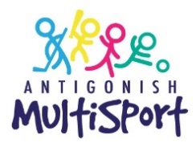

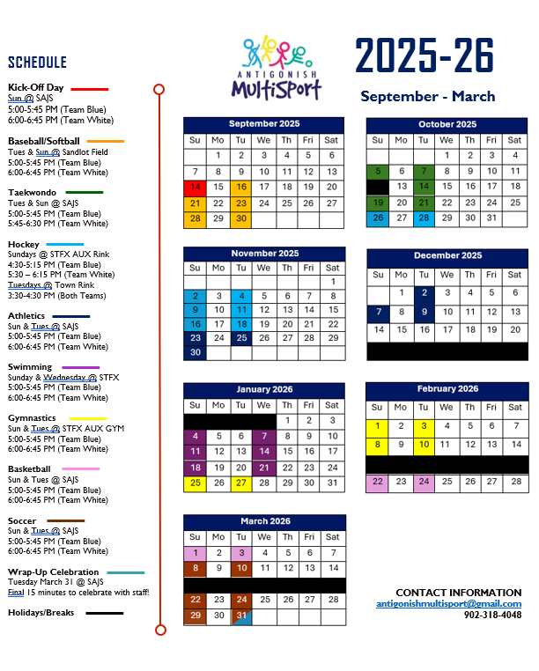
DRAFT SCHEDULE:

